21.43: a) Point charge 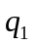 (2.00 nC) is at the origin and 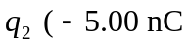) is at 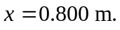
i) At 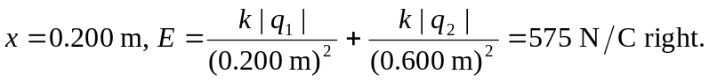
ii) At 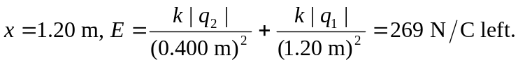
iii) At 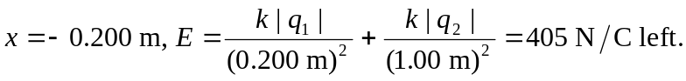
b)

